EXPERIMENT- 4
Q] Write a python program for Crypt-Arithmetic.
Aim-
To solve the Crypt-Arithmetic Problem using Backtracking (Permutation Search) by assigning unique digits to letters such that the arithmetic equation is satisfied.
Algorithm-
- Define the crypt-arithmetic equation (SEND + MORE = MONEY).
- Identify all unique letters in the equation.
- Generate all possible digit assignments (0–9) for the letters.
- Ensure each letter has a unique digit.
- The leading letters (S and M) must not be assigned zero.
- Convert the words into numbers using the assigned digits.
- Check whether the equation is satisfied.
- If a valid assignment is found, display the solution and stop.
Program-
from itertools import permutations
letters = ('S', 'E', 'N', 'D', 'M', 'O', 'R', 'Y')
digits = range(10)
for p in permutations(digits, len(letters)):
S, E, N, D, M, O, R, Y = p
if S == 0 or M == 0:
continue
SEND = S*1000 + E*100 + N*10 + D
MORE = M*1000 + O*100 + R*10 + E
MONEY = M*10000 + O*1000 + N*100 + E*10 + Y
if SEND + MORE == MONEY:
print("Solution Found!\n")
print("SEND =", SEND)
print("MORE =", MORE)
print("MONEY =", MONEY)
print("\nLetter Assignments:")
print("S =", S)
print("E =", E)
print("N =", N)
print("D =", D)
print("M =", M)
print("O =", O)
print("R =", R)
print("Y =", Y)
break
Sample Input-
Crypt-Arithmetic Equation:
SEND + MORE = MONEY
Sample Output-
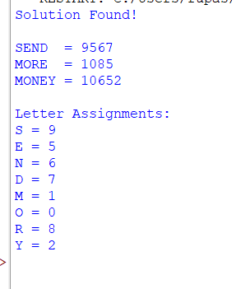

Result-
The Crypt-Arithmetic Problem was solved successfully using the Backtracking (Permutation Search) algorithm, and a valid digit assignment satisfying SEND + MORE = MONEY was obtained.

